Picture | 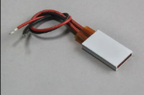 | 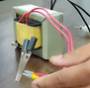 | 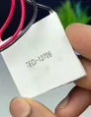 | 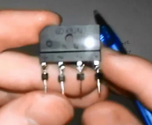 | 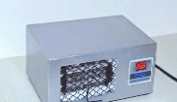 | 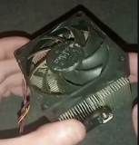 | 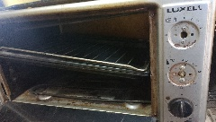
Name | PTC Aluminum Heater Plate | Electric Transformers 12V & 16 V | Thermoelectric Cooler | RECTIFIER BRIDGE | Home AC unit Thermostat | PC Heatsink and Fan | Old Oven Frame
Quantity | 2 pieces | 2 pieces (  16 V 10 A, and 12 V 1 A) | 1 piece | 2 pieces | 1 piece | 1 piece | 1 piece
Description | a heating element of the convection system of the prototype | Turns the unstable alternating current found in households into usable DC. | A cooling element of the convection system of the prototype | Turns the Alternating (AC) current into direct current (DC) | To control the temperature of the prototype | Used for heating and cooling in the convection system of the prototype | The frame of the prototype
Picture | 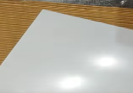 | 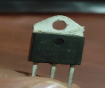 | 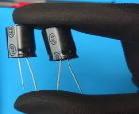 | 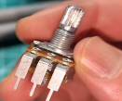 |  | 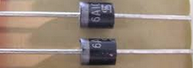 | 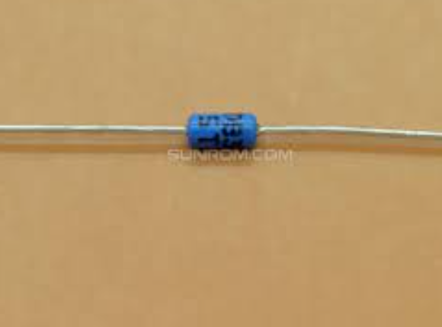
Name | Recycled acrylic | Triac bt136 | Capacitors | Potentiometer | Wires | silicon diodes | Diac db3
Quantity | 1 Pieces | 1 piece | 2 pieces (4500 micro  50 volts, and 470 micro  25 volts) | 2 pieces | From 1 to 1.5 m | 2 pieces | 1 piece
Description | To make the side of the frame | Used in the dimmer circuit to control the light intensity | Softens Direct Current (DC) coming out of the rectifier bridges | Two potentiometers one with 5 kilo ohms and other with 1 mega ohm | A copper wire to connect the circuit | Used for setting the speed of the fan for the heating and the cooling system separately | Used in the dimmer circuit to control the light intensity

